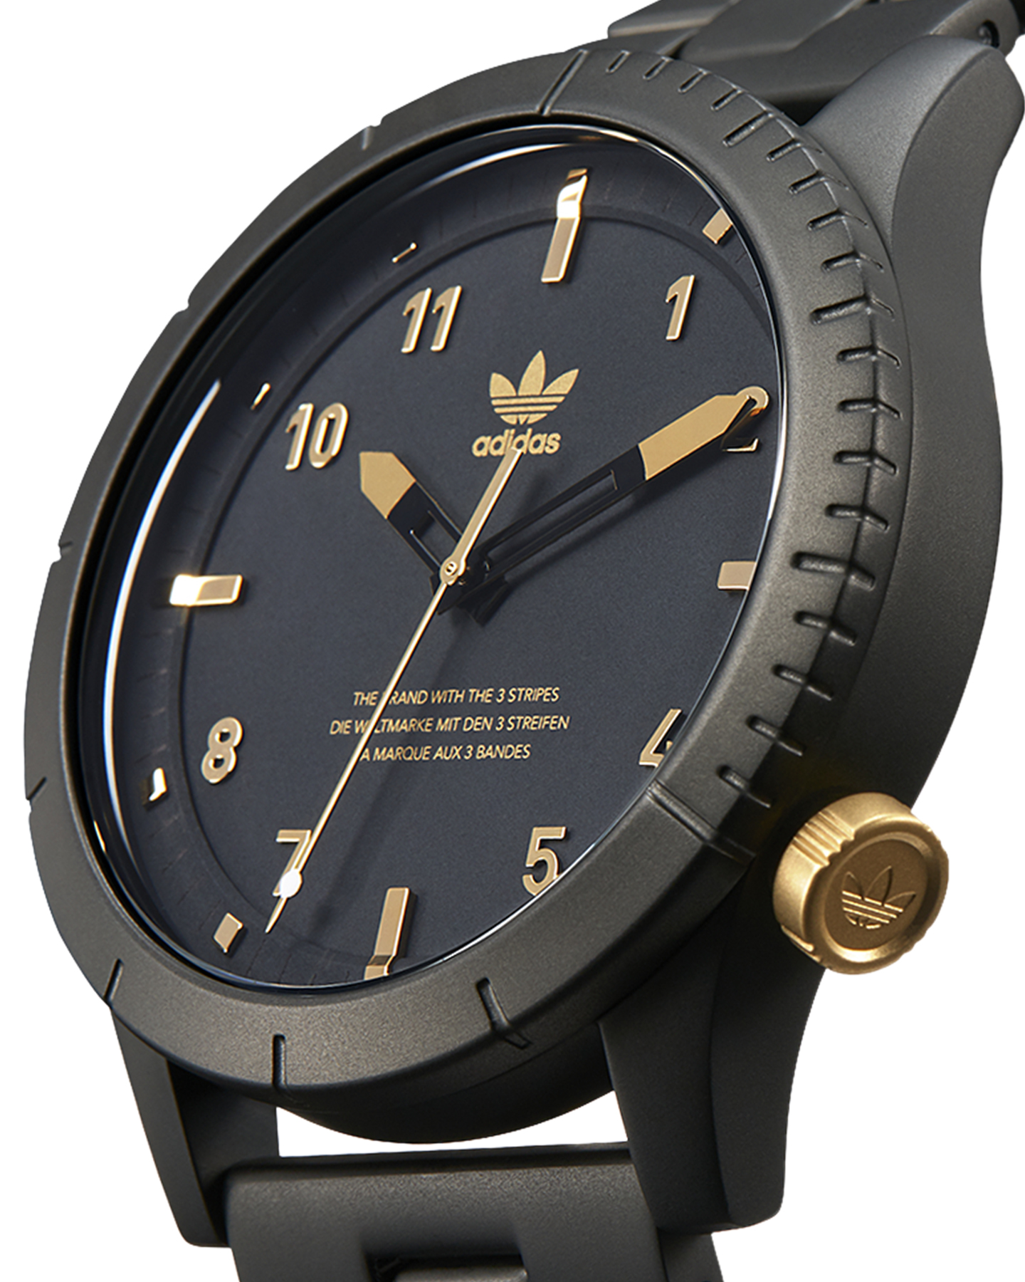Description: Adidas, a globally recognized sports brand, also offers a range of stylish and functional watches designed for athletes and active individuals. Adidas watches combine sporty aesthetics with everyday practicality, making them suitable for both workouts and casual wear. These watches often feature digital and analog displays, water resistance, stopwatch functions, and durable materials to withstand tough conditions. Some models also include fitness tracking features, making them ideal for those who enjoy an active lifestyle. With their modern designs and reliable performance, Adidas watches are a great choice for those who want a perfect blend of fashion, sportiness, and functionality.